# Lab 1. Preparation tasks Template for answers

*Student names and LiU-IDs: (Max 2 students per group):*

*1.*

*2.*

*Submission date:*

*Version (in case you need to re-submit):*

## Basic image operations and data types

1 A) What is the highest pixel value in the image? 253

1 B) What is the maximum value for Image2? 16

1 C) What do you see if you display Image2? Darkened image of the cover book, Digital Image Processing.



1 D) Image3:



1 E) How many gray levels does Image3 have? 255 (+1 for the zero)

1 F) Explain what has happened to the image after these operations! When we first divide image by 16, the values will be rounded to nearest integer. In this case the max becomes 16. Image 2 is then multiplied by 16 so the max becomes 256. Since the value zero should be added to the grayscale. Image 3 becomes also 256.

1 G) Explain the difference between using uint8 images and double images in this task.

By using double. Our pixel values will be limited in a range of [0, 1]. A double precision will though result the same gray scale level and therefore give a better reconstruction of the original image.

1 H) Which class (data type) should you make sure to use when applying such operations to images? Double.

## Contrast stretching and image histogram

2 A) What is the max- and min- values for the image? Max: 0.6980, Min: 0.2902

2 B) Histogram:



2 C) Resulting image after contrast stretching:



2 D) What will the max- and min- values be for the stretched image? Max: 1, Min: 0

2 E) Histogram for the stretched image:



## Image subtraction

3 A) Enhanced difference image:



## Histogram equalization

4 A) Equalized image:



4 B) Histogram for the equalized image:



## Image division and shading correction

5 A) Histogram image:



5 B) Is it possible to find a global threshold to segment this image (look at the histogram)?

No, the shading has to be removed before separating the tiles.

5 C) Recovered image:

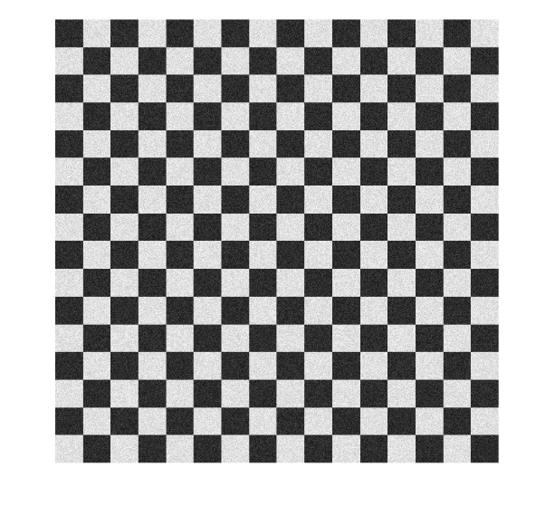

5 D) Histogram of recovered image:



5 E) Segmented image:



5 F) What is the data type (class) for the segmented image? Logical

5 G) How many bits (per pixel) is required to store this type of image?

## RGB-images and indexing

6 A) Image of Swedish flag:

